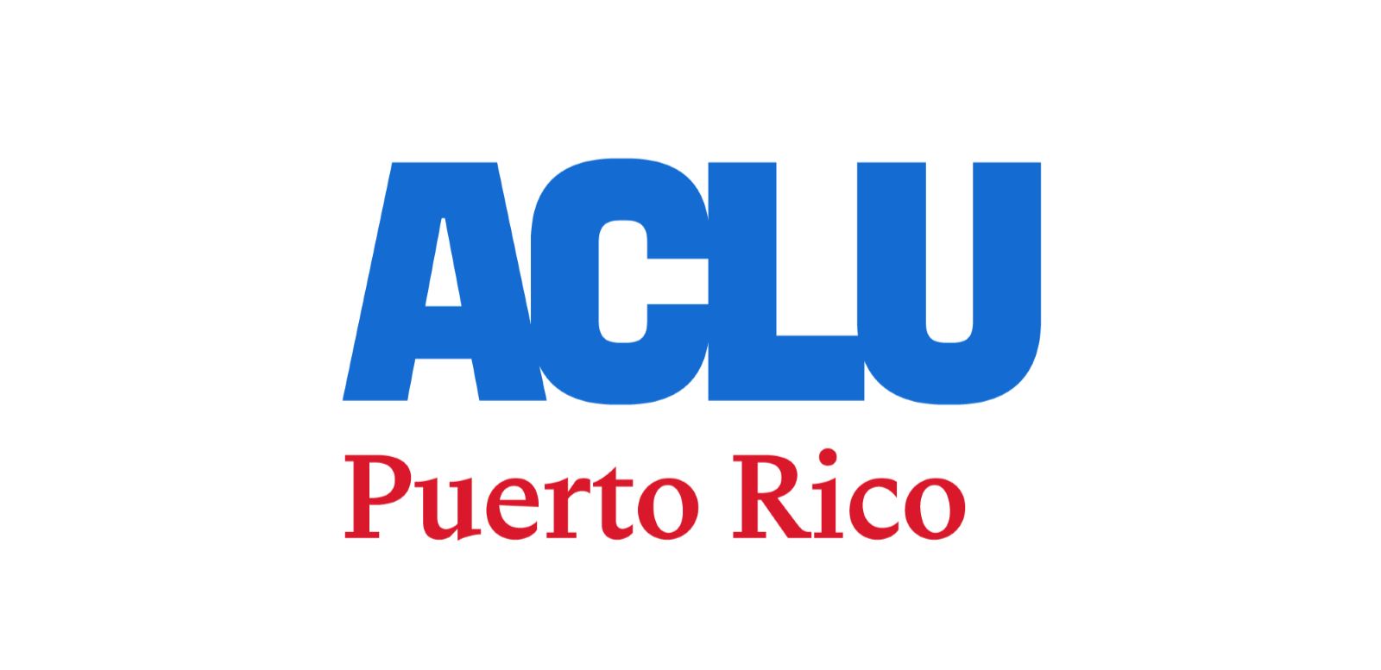
June 22, 2025

Authorized statements from Annette Martínez Orabona, Executive Director of the American Civil Liberties Union (ACLU) of Puerto Rico, regarding the participation in the Puerto Rico Pride March:
"We march in defense of the rights of all people who are part of the LGBTQ+ community, particularly this year for the trans community, which is threatened by multiple laws and bills in the United States and Puerto Rico that seek to undermine their rights and their very existence. We denounce and condemn the approval of Senate Bill 350 and call on the House of Representatives not to approve this measure, which is clearly discriminatory and abusive."

Contact:
David Cordero Mercado
Communications Director – ACLU of Puerto Rico
(787) 247-9057

